**Sales Complaint Queries**

1. **Percentage of Orders with complaints:**

select Sales_Complaints.Complaint_Type,COUNT(Sales_Complaints.Order_ID) * 100/ (select COUNT(Sales_Complaints.Order_ID) from Sales_Complaints) as PCT_Total_Complaint_Orders from Sales_Complaints

group by Sales_Complaints.Complaint_Type;

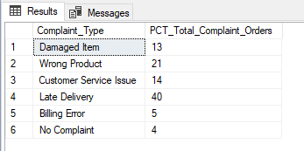

1. **Most Common Complaint Type:**

select Sales_Complaints.Complaint_Type, COUNT(Sales_Complaints.Order_ID) as Total_Complaint_Type from Sales_Complaints

group by Sales_Complaints.Complaint_Type

order by Total_Complaint_Type desc;

